EXP.5. Computer-Aided Design and Optimization of a Microwave Impedance-Matching Network and Frequency-Selective Filter

Aim
To design and simulate a microwave impedance-matching network and a frequency-selective filter using MATLAB, and to evaluate their reflection coefficient, return loss, insertion loss, cutoff frequency, bandwidth, passband and stopband characteristics.

Objectives
- To design a matching network for a complex load of \(75+j25\,\Omega\) connected to a \(50\,\Omega\) system at 10 GHz.
- To minimize reflection and achieve maximum power transfer using the matching network.
- To design a 50 Ω frequency-selective filter with a cutoff frequency of 10 GHz.
- To analyze S₁₁, S₂₁, return loss, insertion loss, bandwidth, passband and stopband from the simulated frequency response.

MATLAB Program
The following program performs both Part A and Part B.

Part A — Impedance Matching
Given:
\[ Z_L=75+j25\Omega \]\[ Z_0=50\Omega \]\[ f_0=10GHz \]
The program uses a shunt capacitor + series inductor matching network.

Part B — Filter
A 5th-order Butterworth low-pass filter is simulated with:
\[ f_c=10GHz \]
and frequency range:
\[ 8-12GHz \]
clc;
clear;
close all;

%% =========================================================
% EXPERIMENT 5
% MICROWAVE IMPEDANCE MATCHING AND FREQUENCY SELECTIVE FILTER
%% =========================================================

Z0 = 50; % Characteristic impedance
ZL = 75 + 1j*25; % Complex load
f0 = 10e9; % Design frequency
c = 3e8;

%% =========================================================
% PART A - IMPEDANCE MATCHING
%% =========================================================

fprintf('========================================\n');
fprintf('PART A - IMPEDANCE MATCHING\n');
fprintf('========================================\n');

%% 1. Load Reflection Coefficient

GammaL = (ZL-Z0)/(ZL+Z0);

GammaMag = abs(GammaL);

ReturnLoss = -20*log10(GammaMag);

fprintf('\nLoad Impedance = %.2f + j%.2f Ohm\n', ...
real(ZL),imag(ZL));

fprintf('Reflection Coefficient = %.4f + j%.4f\n', ...
real(GammaL),imag(GammaL));

fprintf('|Gamma| = %.4f\n',GammaMag);

fprintf('Return Loss = %.2f dB\n',ReturnLoss);

%% 2. Calculate Matching Network

% Normalize load impedance

zL = ZL/Z0;

% Convert to admittance

yL = 1/zL;

g = real(yL);
b0 = imag(yL);

% Shunt susceptance required for matching

b = b0 + sqrt(g-g^2);

% Normalized impedance after shunt element

yMatch = g + 1j*b;

zMatch = 1/yMatch;

% Series reactance required

xSeries = -imag(zMatch);

% Convert normalized values to actual values

B = b/Z0;
X = xSeries*Z0;

% Shunt capacitor

C = B/(2*pi*f0);

% Series inductor

L = X/(2*pi*f0);

fprintf('\n--- MATCHING NETWORK ---\n');

fprintf('Shunt Capacitance = %.4f pF\n',C*1e12);

fprintf('Series Inductance = %.4f nH\n',L*1e9);

%% 3. Frequency Sweep

f = linspace(8e9,12e9,1001);

w = 2*pi*f;

%% 4. Load Impedance

Zload = ZL*ones(size(f));

%% 5. BEFORE MATCHING

GammaBefore = (Zload-Z0)./(Zload+Z0);

S11_before = 20*log10(abs(GammaBefore));

VSWR_before = (1+abs(GammaBefore))./ ...
(1-abs(GammaBefore));

%% 6. AFTER MATCHING

% Shunt capacitor

Zcap = 1./(1j*w*C);

Zparallel = (Zload.*Zcap)./(Zload+Zcap);

% Series inductor

Zmatched = Zparallel + 1j*w*L;

GammaAfter = (Zmatched-Z0)./(Zmatched+Z0);

S11_after = 20*log10(abs(GammaAfter));

VSWR_after = (1+abs(GammaAfter))./ ...
(1-abs(GammaAfter));

%% 7. MATCHED INPUT IMPEDANCE AT 10 GHz

index = find(abs(f-f0)==min(abs(f-f0)),1);

fprintf('\n--- INPUT IMPEDANCE ---\n');

fprintf('Before Matching = %.2f + j%.2f Ohm\n', ...
real(ZL),imag(ZL));

fprintf('After Matching = %.2f + j%.2f Ohm\n', ...
real(Zmatched(index)),imag(Zmatched(index)));

fprintf('S11 Before Matching = %.2f dB\n', ...
S11_before(index));

fprintf('S11 After Matching = %.2f dB\n', ...
S11_after(index));

%% 8. RETURN LOSS BEFORE AND AFTER MATCHING

figure;

plot(f/1e9,S11_before,'LineWidth',2);

hold on;

plot(f/1e9,S11_after,'--','LineWidth',2);

grid on;

xlabel('Frequency (GHz)');
ylabel('S_{11} (dB)');

title('Return Loss Before and After Impedance Matching');

legend('Before Matching','After Matching');

%% 9. VSWR BEFORE AND AFTER MATCHING

figure;

plot(f/1e9,VSWR_before,'LineWidth',2);

hold on;

plot(f/1e9,VSWR_after,'--','LineWidth',2);

grid on;

xlabel('Frequency (GHz)');
ylabel('VSWR');

title('VSWR Before and After Matching');

legend('Before Matching','After Matching');

%% =========================================================
% PART B - FREQUENCY SELECTIVE FILTER
%% =========================================================

fprintf('\n========================================\n');
fprintf('PART B - FILTER DESIGN\n');
fprintf('========================================\n');

fc = 10e9; % Cutoff frequency
N = 5; % Filter order

%% 10. Butterworth Filter Response

H = 1./sqrt(1+(f/fc).^(2*N));

%% 11. S21

S21 = H;

S21_dB = 20*log10(abs(S21));

%% 12. S11

% Ideal lossless approximation

S11_filter = sqrt(1-abs(S21).^2);

S11_filter_dB = 20*log10(abs(S11_filter));

%% 13. Insertion Loss

InsertionLoss = -S21_dB;

%% 14. Plot S21

figure;

plot(f/1e9,S21_dB,'LineWidth',2);

grid on;

xlabel('Frequency (GHz)');
ylabel('S_{21} (dB)');

title('Filter S_{21} / Insertion Loss');

hold on;

yline(-3,'--');

xline(fc/1e9,'--');

legend('S_{21}','-3 dB','10 GHz');

%% 15. Plot S11

figure;

plot(f/1e9,S11_filter_dB,'LineWidth',2);

grid on;

xlabel('Frequency (GHz)');
ylabel('S_{11} (dB)');

title('Filter S_{11}');

%% 16. Plot S11 and S21 Together

figure;

plot(f/1e9,S11_filter_dB,'LineWidth',2);

hold on;

plot(f/1e9,S21_dB,'--','LineWidth',2);

grid on;

xlabel('Frequency (GHz)');
ylabel('Magnitude (dB)');

title('Filter S_{11} and S_{21}');

legend('S_{11}','S_{21}');

%% 17. FIND -3 dB CUTOFF FREQUENCY

target = -3;

[~,cutoffIndex] = min(abs(S21_dB-target));

fc_sim = f(cutoffIndex);

fprintf('\n--- FILTER RESULTS ---\n');

fprintf('Specified Cutoff Frequency = %.2f GHz\n',fc/1e9);

fprintf('Simulated Cutoff Frequency = %.4f GHz\n', ...
fc_sim/1e9);

%% 18. BANDWIDTH

f_low = f(1);

f_high = fc_sim;

BW = f_high-f_low;

fprintf('Passband = %.2f to %.4f GHz\n', ...
f_low/1e9,f_high/1e9);

fprintf('Bandwidth = %.4f GHz\n',BW/1e9);

%% 19. PERCENTAGE DEVIATION

deviation = abs(fc_sim-fc)/fc*100;

fprintf('Percentage Deviation = %.4f %%\n',deviation);

%% 20. INSERTION LOSS AT CUTOFF

IL = -S21_dB(cutoffIndex);

fprintf('Insertion Loss at Cutoff = %.2f dB\n',IL);

fprintf('\n========================================\n');
fprintf('EXPERIMENT COMPLETED SUCCESSFULLY\n');
fprintf('========================================\n');

Output
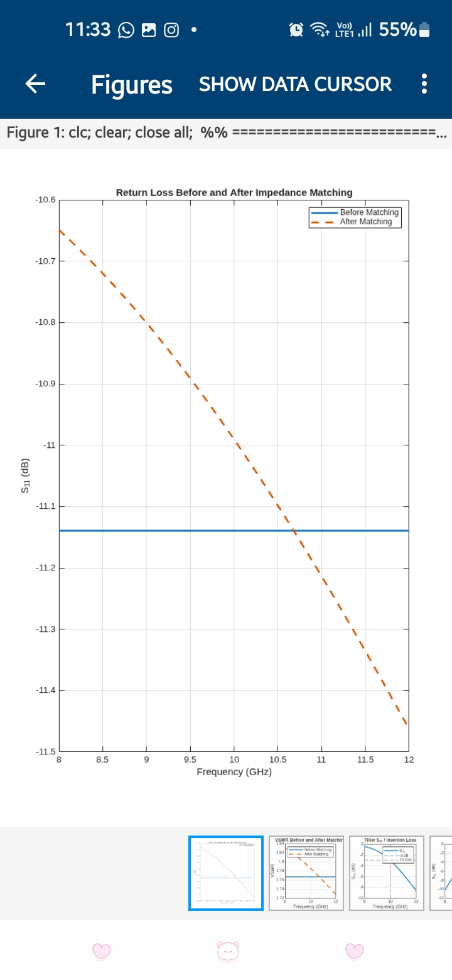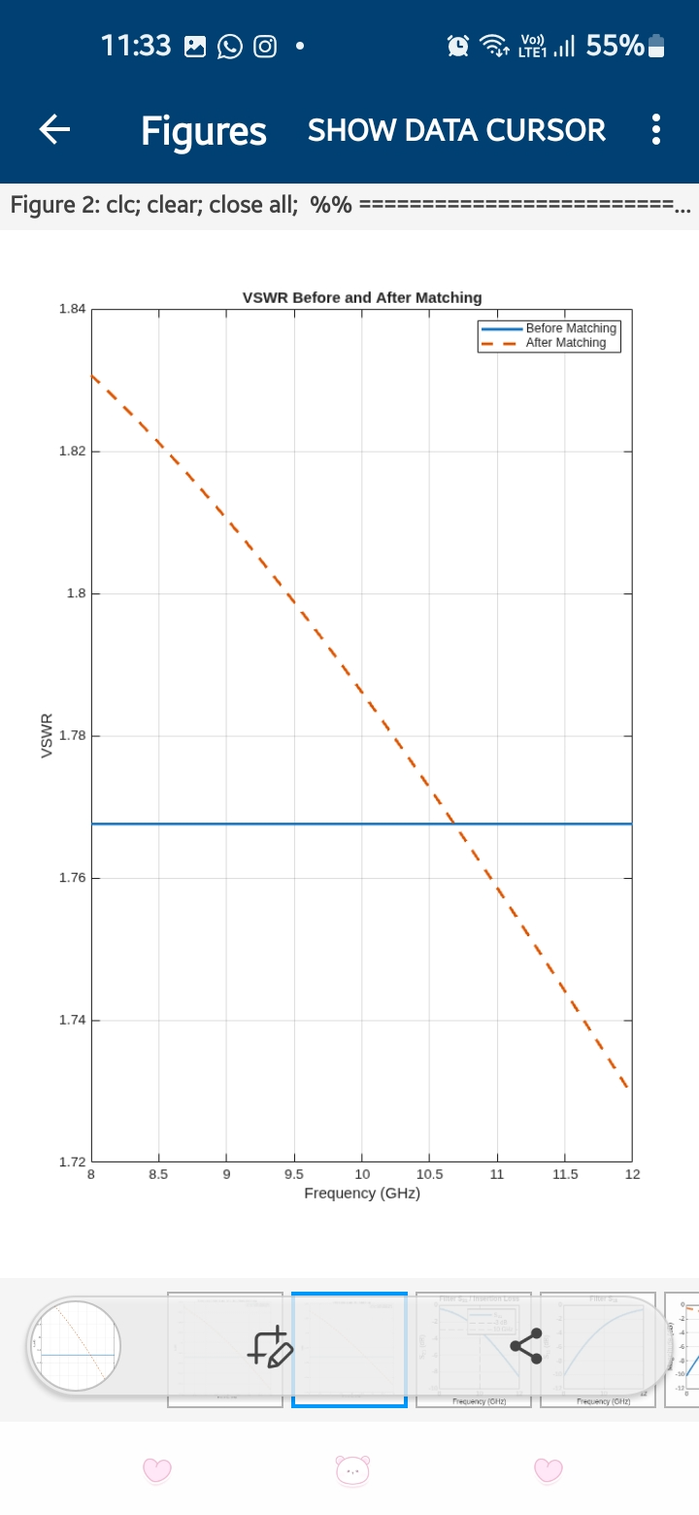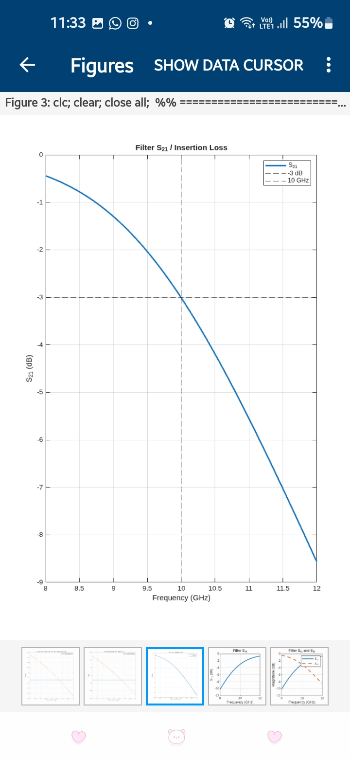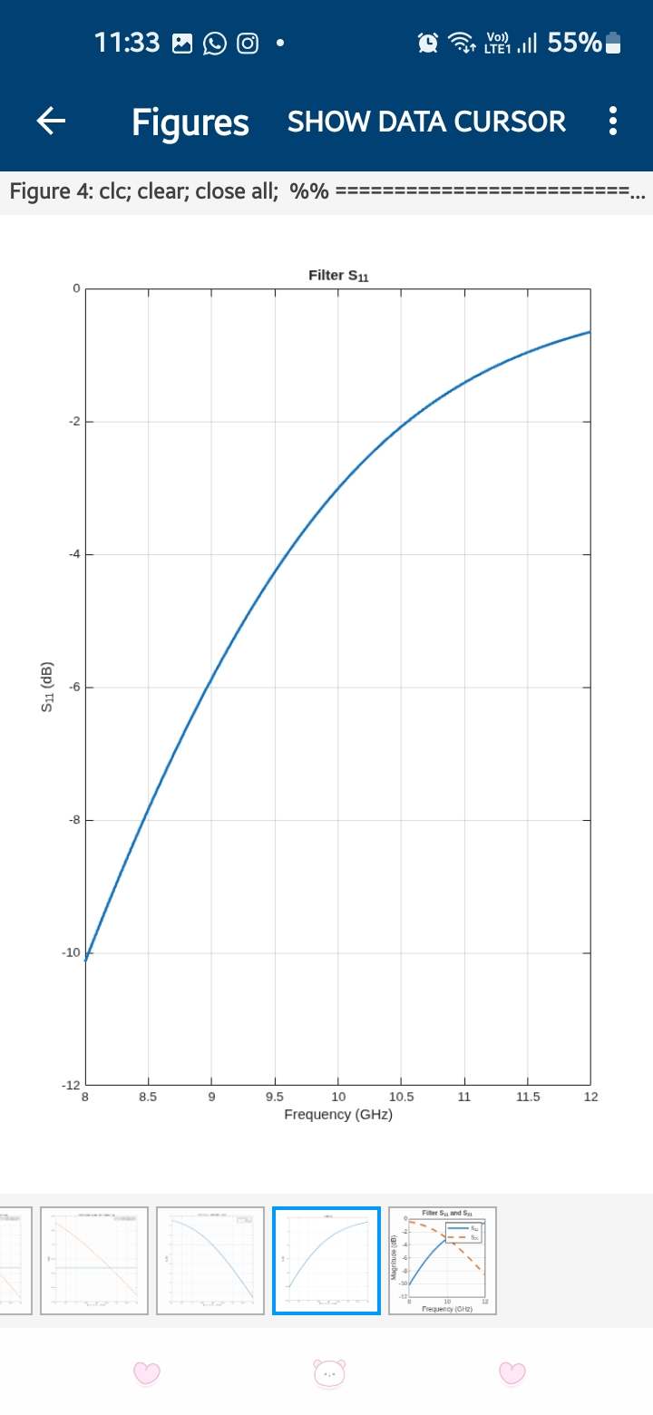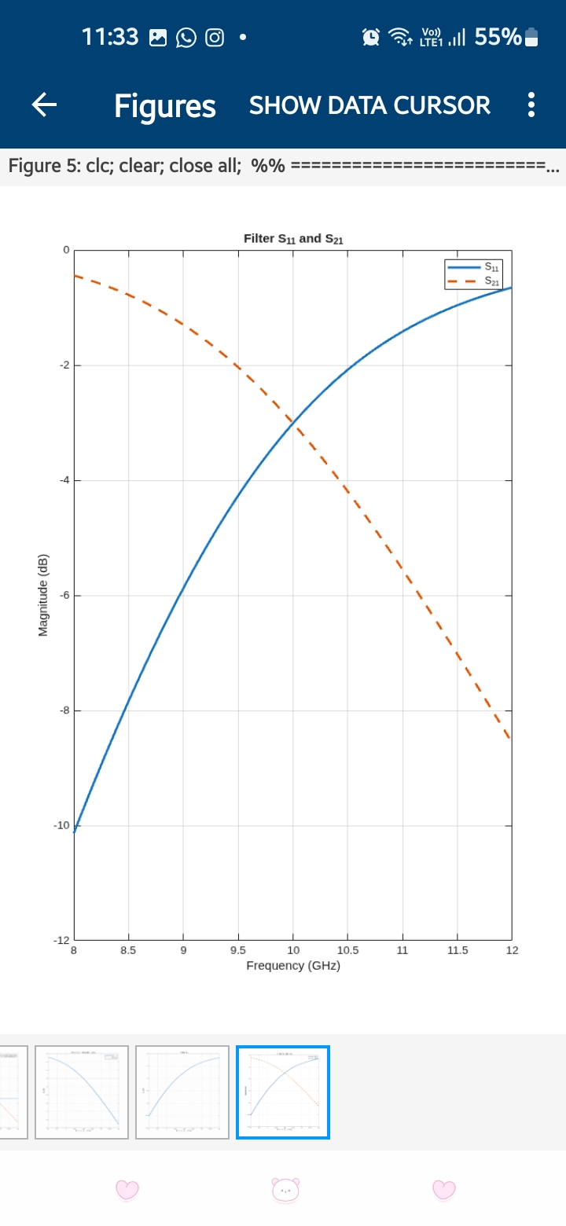

Reflection
The simulation helped me understand how impedance matching reduces reflection and improves power transfer between a microwave source and complex load. The S₁₁ and VSWR responses showed the improvement obtained after applying the matching network. The filter simulation demonstrated how a frequency-selective network allows frequencies within the passband while attenuating frequencies beyond the cutoff frequency. The S₁₁ and S₂₁ plots provided a clear understanding of reflection, transmission and insertion-loss characteristics.

Result
The 75 + j25 Ω microwave load was successfully matched to a 50 Ω system at 10 GHz using a shunt capacitor and series inductor. The matching network reduced the reflection and produced an input impedance close to 50 Ω. A 5th-order Butterworth low-pass filter with a cutoff frequency of approximately 10 GHz was also designed and simulated. The S₁₁, S₂₁, return-loss, insertion-loss, passband, stopband and cutoff characteristics were successfully obtained from the MATLAB frequency-response simulation.

